There are 4 print screens/code copy, each worth 25%

**This homework is based on Chapter 11 (Exceptions and Advanced IO)**

1. Complete programming challenges #1 below:

**#1 print screen your output below here**

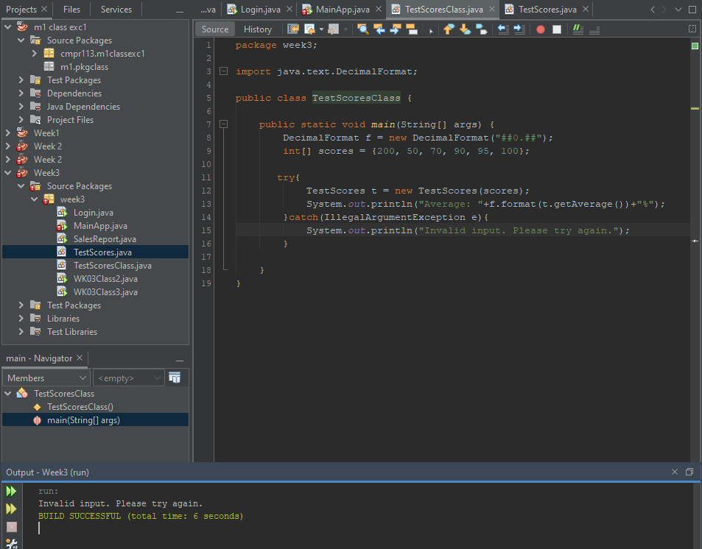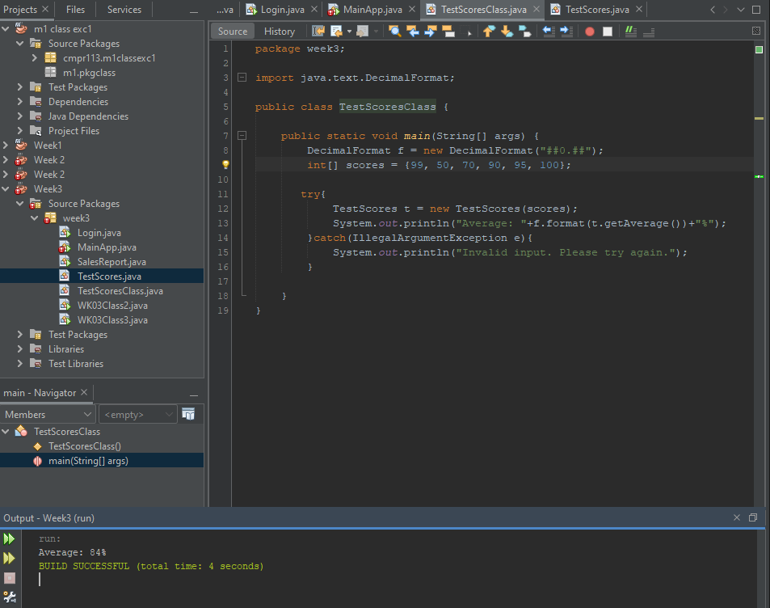

**#2 copy and paste your code below here**

package week3;

import java.text.DecimalFormat;

public class TestScoresClass {

public static void main(String[] args) {

DecimalFormat f = new DecimalFormat("##0.##");

int[] scores = {200, 50, 70, 90, 95, 100};

try{

TestScores t = new TestScores(scores);

System.out.println("Average: "+f.format(t.getAverage())+"%");

}catch(IllegalArgumentException e){

System.out.println("Invalid input. Please try again.");

}

}

}

package week3;

public class TestScores{

private int total=0;

private double average;

public TestScores(int[] array) {

for(int n : array){

if(n<0||n>100){

throw new IllegalArgumentException();

}

total+=n;

}

average=(double)total/array.length;

}

public double getAverage(){

return average;

}

}

1. Complete programming challenges #6 (be sure to use the writer and reader classes)

**#3 print screen your output below here**

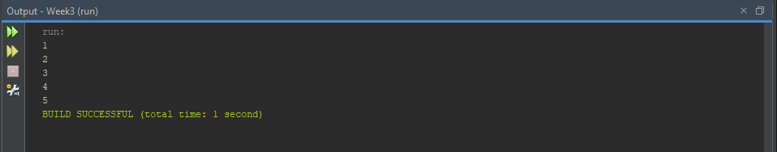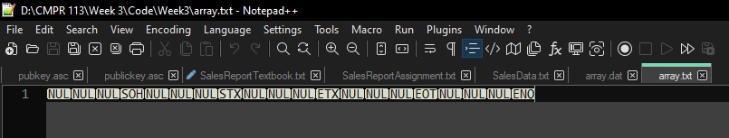

**#4 copy and paste your code below here**

**package week3;**

import javax.swing.JOptionPane;

public class FileArrayClass {

public static void main(String[] args) throws Exception {

int[] array = {1,2,3,4,5};

int[] newArray = new int[array.length];

FileArray f = new FileArray();

f.writeArray("array.txt", array);

f.readArray("array.txt", newArray);

for(int i : newArray)

System.out.println(i);

}

}

**Submit this document to Module 3 Homework #3**